Data Description:

Data to be used for the clustering is venue information from Foursquare. Foursquare attempts to provide a comprehensive list of venues within a metropolitan area. There are a few challenges encountered when using this data. The first is that the limits on the quantity of returned data points often yields a cluster of venues very close to the search latitude and 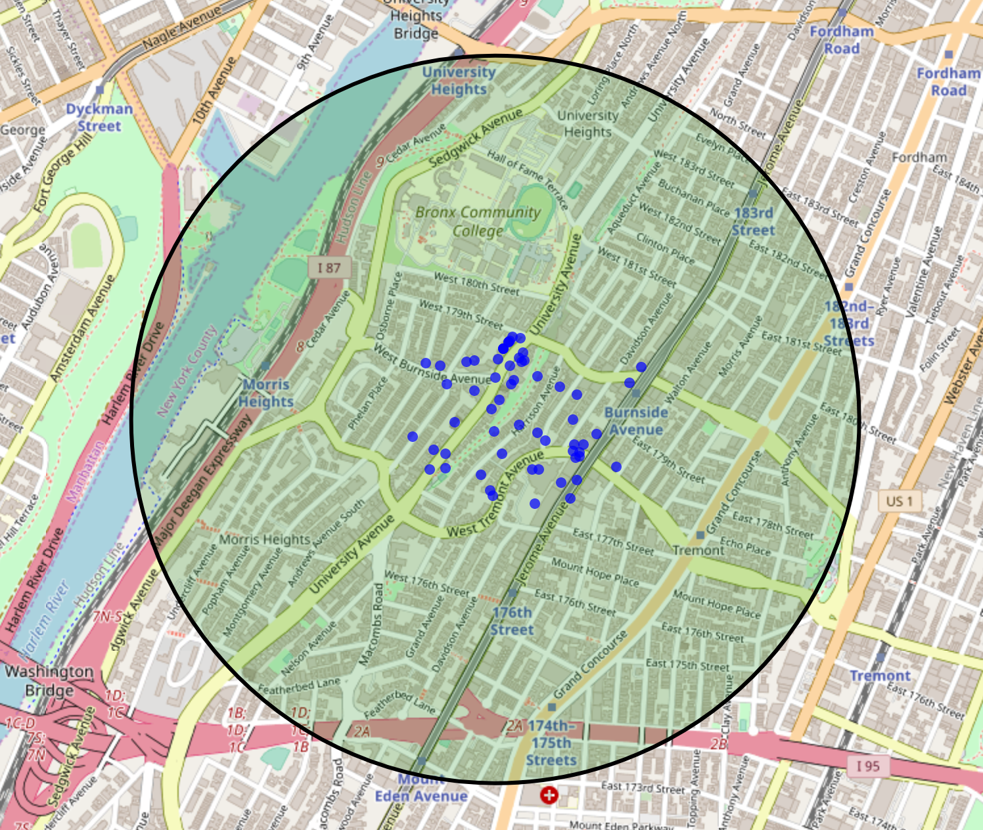longitude (the ‘center’ of the search), and sparse data at the fringes of the neighborhood (figure 1).

This can be overcome, somewhat, by varying the search coordinates slightly, and adding unique results found for searches at these nearby points to the venue data for a give neighborhood.

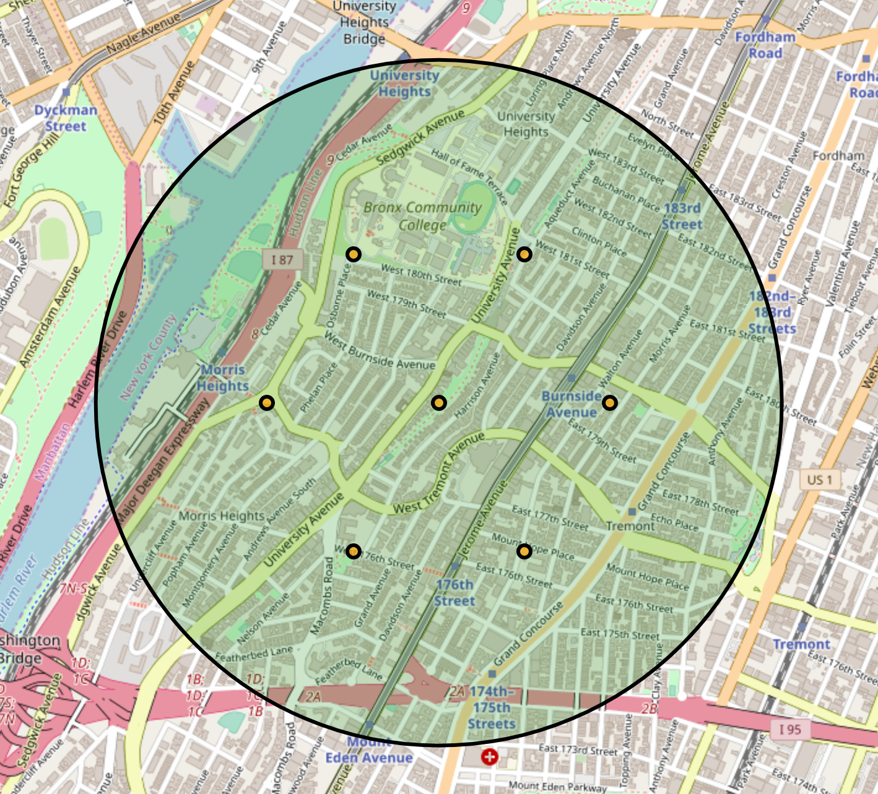The decision to harvest a larger set of venues for each neighborhood is supported by searching a rosette pattern of locations surrounding the center of the neighborhood (Figure 2). A decision to include 7 points to search for each neighborhood was based on the tradeoff of additional searches required (Foursquare limits the number of queries allowed per day from a single API key) and the harvesting of unnecessary duplicate venues from Foursquare.

Figure 1: Foursquare data returned from a single search. Blue dots are the locations of returned venues, green shaded region shows the requested search radius.

Using multiple points provided a much better set of venues for the test neighborhood. When the duplicates are eliminated, and venues that fall outside the neighborhood were dropped, the resulting set of venues harvested provided adequate coverage for the entire neighborhood (figure 3).

Figure 2: A rosette of 6 additional search points created around the primary (central) point defining a neighborhood.

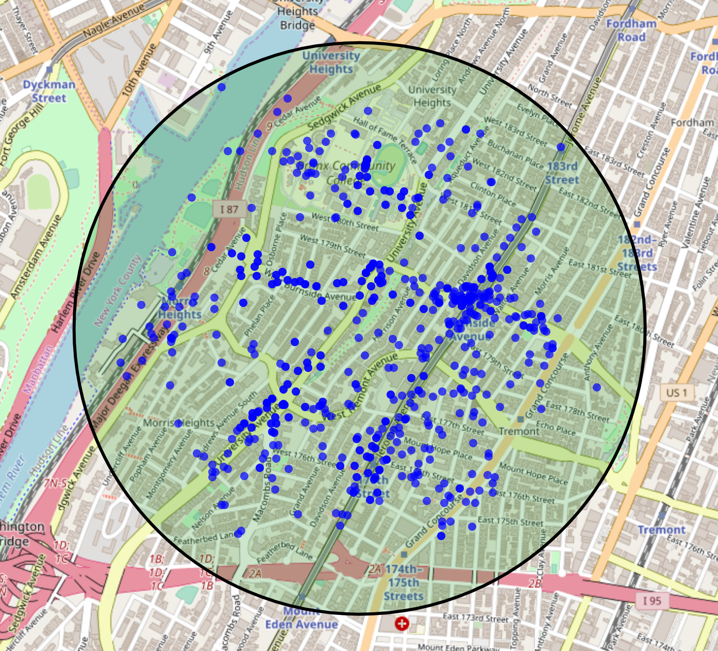

The taxonomy of descriptions found in the ‘Category’ field in the foursquare database is poorly documented, and searches often yield unique category counts that exceed 50% of the total number of venues returned. Increasing the number of venues considered for a neighborhood would provide a better representation of the ‘flavor’ of a neighborhood. Alternative approaches would be to provide more specific search categories, and using the results of multiple searches to provide a list of venues that are actively considered important to the researcher.

Figure 3: Unique venues returned from a series of 7 searches located throughout the neighborhood

Foursquare also has a set of general categories, that collect the 456 categories into 10 general categories. These parent categories may provide aggregation that creates a more consistent and comparable model for the venues in a neighborhood, but are not returned by the foursquare endpoints, so creating a database that links the specific categories returned by a search to their more general (parent) groups will be required. The category listing includes 10 top level categories, some of which hold up to four levels of subcategories within them. The top level category with the most subcategories is, unsurprisingly, ‘food’ which includes restaurants, grocery stores, and specialty food shops.